Earth Shard

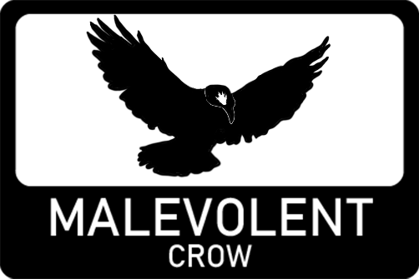

Proposal

Version 2.0

Contents

2 Overview 4

2.1 Project brief 4

2.2 Narrative 4

2.3 Gameplay 4

3 Marketing 4

3.1 Current market 4

3.2 Target audience 5

3.3 Unique selling points 5

3.3.1 Unique gameplay mechanics for fighting and solving puzzles. 5

3.3.2 Timed levels for replay ability. 5

3.3.3 Low-poly aesthetic with dessert/arid theme. 5

4 Mechanics 5

4.1 Movement 5

4.2 Abilities 5

4.2.1 Rock throw 6

4.2.2 Ground raise 6

4.3 Health system 6

4.4 Rock golems 6

4.5 Switches 7

4.6 Signs 7

4.7 Level timer 7

5 User Interface 7

5.1 HUD 7

5.2 Menus 8

6 Design 8

6.1 Ability animations 8

6.2 Rock golems 9

6.3 Environment 9

7 Levels 10

7.1 Level 1 10

7.2 Level 2 10

7.3 Level 3 10

7.4 Level 4 10

8 Development 11

8.1 System specifications 11

8.2 Development method 11

8.3 Asset acquisition 11

# Overview

## Project brief

Earth Shard is a project being developed for HND graded unit 2. This project will showcase the best of my abilities I have developed through the HNC and HND.

## Narrative

You take on the role of a mage who can manipulate earth! But before you can enter the league of the elementalists you must first pass 4 trials to prove yourself as an initiate of earth manipulation.

## Gameplay

Earth Shard is a 3D first-person action game and puzzle game. The goal of Earth Shard is to progress through 4 levels and take advantage of your 2 abilities to defeat enemies and solve puzzles.

# Marketing

## Current market

Earth Shard takes inspiration from games like [portal](https://store.steampowered.com/app/400/Portal/?curator_clanid=4777282) with its puzzle mechanics and adapts the idea present in the game [RUMBLE](https://store.steampowered.com/app/890550/RUMBLE/?curator_clanid=4777282) into a more puzzle like single player experience.

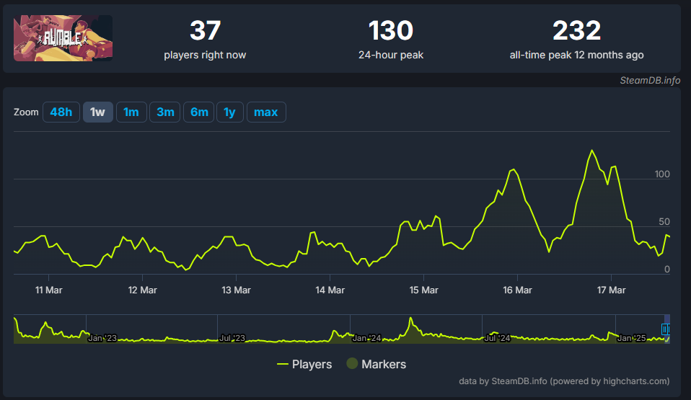

RUMBLE currently has a low player base due to being a PvP VR game which limits its audience. Earth Shard will expand upon the earth magic ideas present in this game in a simpler form that works better for single player experience.

The puzzles present in Earth Shard are unique physics-based puzzles which although are far different from games like portal, that style of physics-based puzzle games has very much inspired Earth Shard.

## Target audience

Earth Shard will be aimed towards players who are a fan of fantasy themes, action games and puzzle games. The age rating of Earth Shard will be 12 and above. The Pegi rating will also be 12 as the game contains fantasy violence.

## Unique selling points

### Unique gameplay mechanics for fighting and solving puzzles.

Earth Shard uses physics elements to fight enemies, meaning the player must aim to get rocks to move at the right trajectories to hit enemies or switches.

### Timed levels for replay ability.

Each level in earth shard will be timed allowing the player to go back and replay the level and attempt to beat the previous time.

### Low-poly aesthetic with dessert/arid theme.

Earth shard takes place in an arid rocky desert with magical creatures. Earth shard also has a consistent low poly design.

# Mechanics

## Movement

Earth Shards movement will follow a recognisable mouse and keyboard scheme, with WASD for movement and mouse for camera control. This will be easy for players of the target audience to pick up as it is a familiar scheme used by most modern first-person games.

## Abilities

There are two main abilities in Earth Shard. The Rock Throw and Ground Raise.

These abilities are unlocked as the player plays progresses through level 1 to level 2.

The player can switch between the abilities with the number keys or scroll wheel, the active ability will be displayed on the crosshair.

### Rock throw

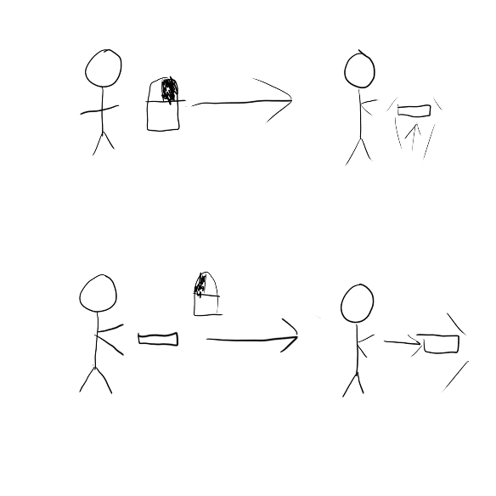The rock throw ability allows the player to raise a rock from the ground and throw it at the enemies or switches. It will damage the enemies and activate the switches.

### Ground raise

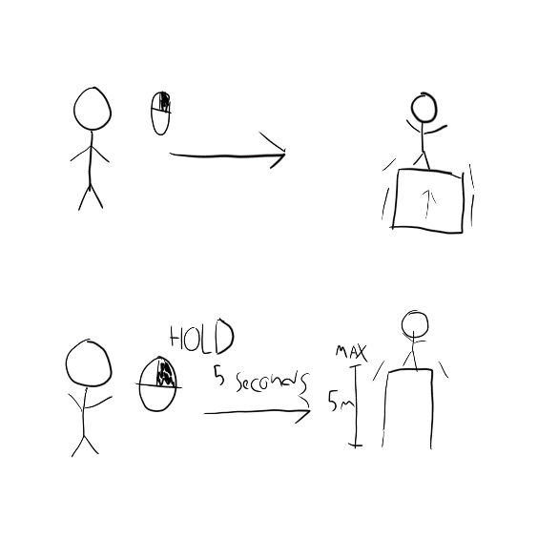This is a non-offensive ability that allows the player to raise themselves off the ground. It has a maximum of 5 metres and will raise 1 metre per second the button is held. This will allow the player to get too hard-to-reach places.

## Health system

The health system will not be directly displayed as a red glow around the edges of the screen when the player is hurt. The player will heal out of combat slowly over time.

## Rock golems

The rock golems will use a state machine to control different AI behaviours to create dynamic interactions with the player. The rock golems will throw rocks at the player damaging them.

See Rock golem design.

## Switches

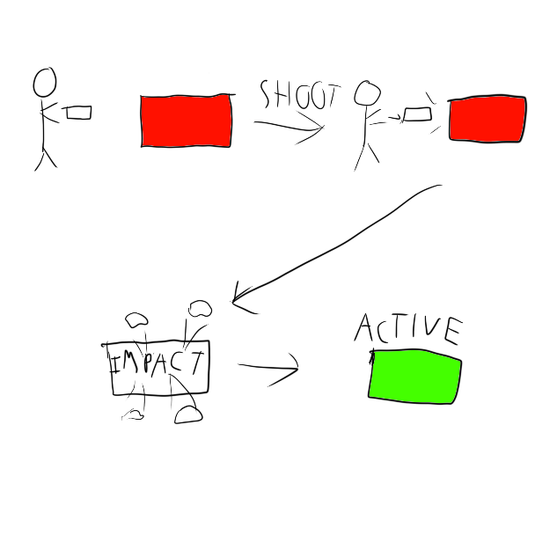Switches must have rocks thrown at them to activate them. On activation they can open doors and trigger events.

## Signs

The player will be able to interact with signs that will give any necessary tutorial information for abilities or game lore. These signs will be sprinkled throughout the levels.

## Level timer

Each level will have a timer displayed at the top of the HUD showing current time. Upon beating the level, the player will be taken to a screen showing final time.

# User Interface

## HUD

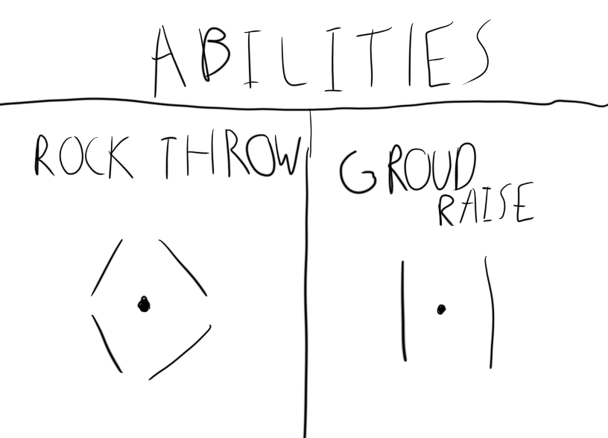The HUD will be rather simple for immersion. the crosshair will have different designs depending on what ability is equipped. The HUD will also display health as red glow around the screen when it is low.

At the top of the screen a timer will be displayed that so the player can replay levels for a better time.

## Menus

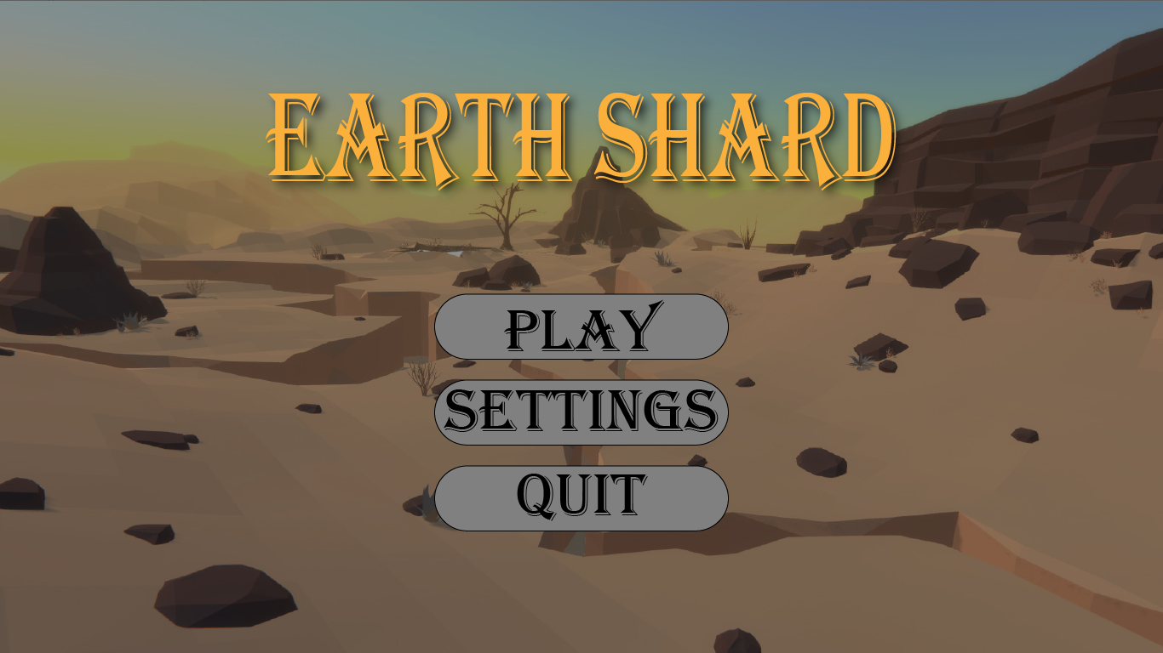

Earth shard will have 4 menus: the main menu, the settings menu, the credits menu and an end level screen.

The end level screen will display a time that is stored so the player can replay levels for better times.

# Design

## Ability animations

The player will have hands displayed in front of them that will play certain animations based on what ability is equipped.

With the rock throw ability, the players hands will raise a rock from the ground and when fire the players hands will extend, and the rock will be thrown.

## Rock golems

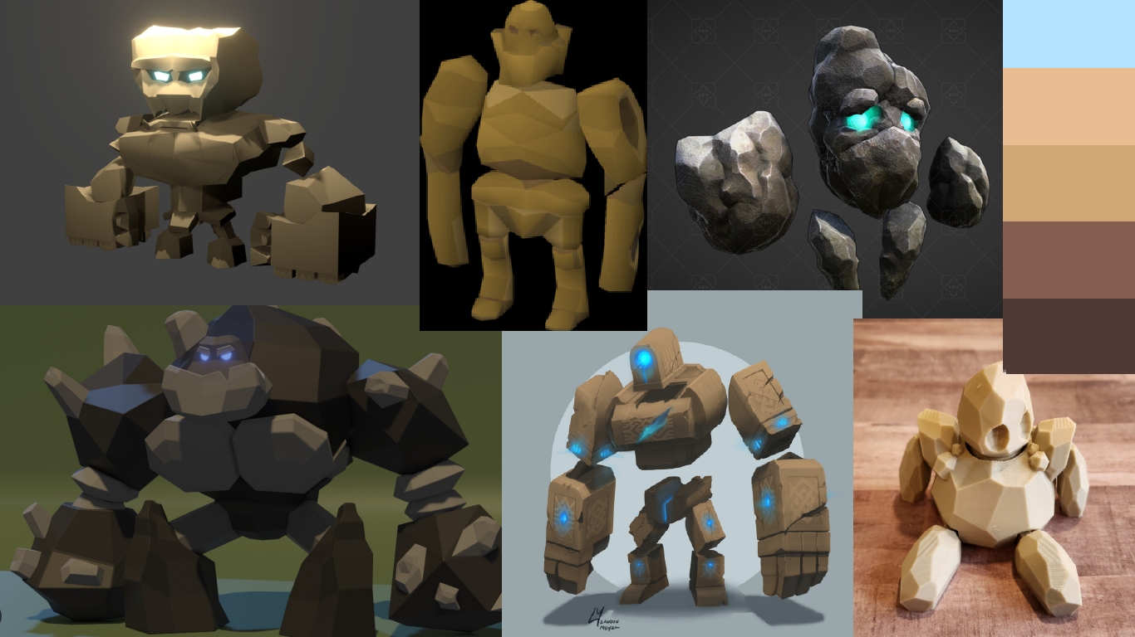

Rock Golems will follow the low poly aesthetic and take on rock colours like the environment. The rock golems will match the environment as if they have came alive from the very rocks around them.

See rock golem mechanics.

## Environment

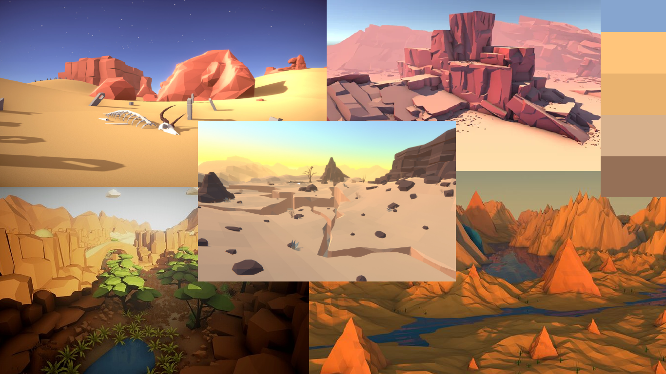

The environment of earth shard will be arid and mountainous. As the earth shard works around the magic of manipulating the earth and rock, a very rocky and arid environment is fitting.

# Levels

Earth Shard will have 4 levels. Each level will introduce a new feature except for the last level as it will combine all challenges of the previous levels into the ultimate challenge.

At the end of each level the player will be given an end screen showing a time.

## Level 1

Level 1 introduces the player too rock throw ability and rock golems. This level aims to teach the player how to use the rock throw to defeat enemies. This level also teaches the player about the health system too as the rock golems will attack the player.

## Level 2

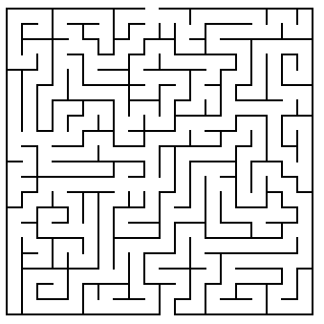Level 2 introduces the switches; enemies will be fewer and can be optionally avoided. This level will take place in a labyrinth with a door that is locked at the end. To open the door the player must find 3 witches around the labyrinth in order open the door at the end which will complete the level.

## Level 3

Level 3 introduces the ground raise ability. The player will have to climb out of a pit using this ability to platform their way out. There will also be switches that open sections and enemies sprinkled throughout.

## Level 4

Level 4 will combine all the challenges of before with more enemies. this level will test the players skills as they will need to solve puzzles white fighting enemies.

When this level concludes it will show the player a normal end screen before being taken to a congratulations screen for completing the game.

# Development

## System specifications

These are minimum requirements found for games of a similar scale too earth shard.

**Minimum requirements:** Pentium 4 processor (3.0GHz, or better), 1GB RAM, DirectX® 9 level Graphics Card, Windows® 7 (32/64-bit)/Vista/XP, Mouse, Keyboard

## Development method

Earth Shard will use a hybrid agile methodology of kanban. Kanban by itself does not use sprints or Gannt charts but due to this being a requirement for the project there will be one made for an initial project plan. Through development though kanban will be utilised as it makes keeping track of tasks much easier. The main bulk of the projects tracking will be done through Github as it directly integrates into the project itself making bug tracking and updating tasks very quick and easy.

## Asset acquisition

Majority of the 3D assets will be acquired through 3rd party sources such as the unity asset store and sketchfab. This is due to 3D assets requiring a lot of time to produce. But a low-poly aesthetic has been chosen meaning if any assets must be produced by myself, they will be easier to make.